**MOTION ACTIVATED SURVEILLANCE CAMERA**

**A Project Report**

**Submitted by**

**Logesh G**

**Srinivasan V**

**Ram prasath G**

**Kaviyarasan S**

**BACHELOR OF ENGINEERING**

***in***

**ELECTRONICS AND COMMUNICATION ENGINEERING**

 

**VELAMMAL ENGINEERING COLLEGE (AUTONOMOUS) , CHENNAI-66**



ANNA UNIVERSITY:: CHENNAI 600 025

**EVEN SEM 2023-24**

**APPENDIX 2**

**VELAMMAL ENGINEERING COLLEGE: CHENNAI 600 066**

**BONAFIDE CERTIFICATE**

Certified that this project report **“MOTION ACTIVATED SURVEILLANCE CAMERA”** is the bonafide work of **Logesh G; Srinivasan V; Ramprasath G; Kaviyarasan S;** who carried out the project work under my supervision.

**Mr.K .Radhakrishnan Dr.S. MARY JOANS**

**Supervisor Professor & Head**

**Department of Electronics and Department of Electronics and Communication Engineering Communication Engineering Velammal Engineering College Velammal Engineering College Chennai -600066 Chennai - 600066**

**TABLE OF CONTENT**

|  |  |  |
| --- | --- | --- |
| **S.NO** | **CONTENT** | **PAGE NO** |
| 1 | ABSTRACT | 4 |
| 2 | OBJECTIVE | 5 |
| 3 | LITERATURE SURVEY | 5 |
| 4 | BLOCK DIAGRAM | 8 |
| 5 | HARDWARE DETAILS | 8 |
| 6 | SOFTWARE DETAILS | 9 |
| 7 | DESCRIPTION | 9 |
| 8 | APPLICATIONS | 10 |
| 9 | OUTCOME OF THE PROJECT | 11 |
| 10 | REFERENCES: | 11 |

# ABSTRACT:

This paper introduces an innovative approach the "Motion Activated Surveillance Camera" mini-project aims to develop a cost-effective surveillance system that triggers recording and capture the photocopy of motion detection. The system integrates motion detection algorithms with a camera module, enabling recording of detected motion events. The project involves hardware components such as Arduino, or similar microcontrollers, coupled with a camera module and motion detection sensors. Software development includes programming the microcontroller to interface with the camera and motion sensors, implementing motion detection algorithms, and configuring alert mechanisms. The system's applications span from home security to monitoring industrial spaces, enhancing surveillance efficiency and responsiveness. This mini-project offers insights into the integration of hardware and software components for developing a motion-based surveillance solution with practical applications.

# OBJECTIVE:

The objective of this mini project is to develop a technical project to enable immediate notification to users via Telegram when motion is detected in the monitored area, facilitating rapid response to potential security threats or suspicious activities. Allow users to remotely monitor their surroundings by receiving images captured by the ESP32-CAM module through the Telegram bot, providing them with real-time visual feedback regardless of their physical location.

Ensure seamless integration between the ESP32-CAM module, PIR sensor, and Telegram bot, creating a cohesive system that effectively detects motion, captures images, and delivers notifications without requiring manual intervention.

**LITERATURE SURVEY:**

1. **Technological Advances**: Research on the latest advancements in motion detection algorithms, sensor technologies (such as infrared, ultrasonic, microwave, and video-based motion sensors), and image processing techniques used in surveillance cameras.
2. **Detection Performance**: Studies evaluating the accuracy, sensitivity, and reliability of motion detection algorithms in different environmental conditions (e.g., lighting variations, weather conditions, and background clutter).
3. **Integration with AI and Machine Learning**: Exploration of how artificial intelligence (AI) and machine learning techniques are integrated into surveillance systems to improve motion detection accuracy, reduce false alarms, and enhance intelligent video analytics capabilities.
4. **Energy Efficiency**: Research focusing on energy-efficient motion detection techniques and low-power sensor designs for battery-operated surveillance cameras, especially in remote or outdoor environments.
5. **Privacy and Ethical Considerations**: Examination of privacy concerns and ethical implications associated with the use of motion-detected surveillance cameras, including data privacy, consent, and potential misuse of surveillance footage.
6. **Applications and Case Studies**: Literature on real-world applications of motion-detected surveillance cameras in various domains such as home security, public safety, traffic monitoring, retail analytics, and industrial surveillance. Case studies highlighting successful deployments and lessons learned could provide valuable insights.
7. **Wireless Communication Protocols**: Studies on wireless communication protocols (e.g., Wi-Fi, Bluetooth, Zigbee) used for transmitting video streams and alerts from surveillance cameras to monitoring stations or mobile devices.
8. **Robustness and Reliability**: Research focusing on the robustness and reliability of surveillance systems against tampering, interference, and cyber-attacks, including techniques for secure data transmission and storage.
9. **User Experience and Interface Design**: Analysis of user requirements, preferences, and feedback regarding the usability, accessibility, and user interface design of motion-detected surveillance camera systems.

**BLOCK DIAGRAM:**

**SD Card**

**ESP 32 CAM**

**MODULE**

**PIR Senior**

**Power Supply**

**Motion**

**detection**

**CIRCUIT DIAGRAM:**

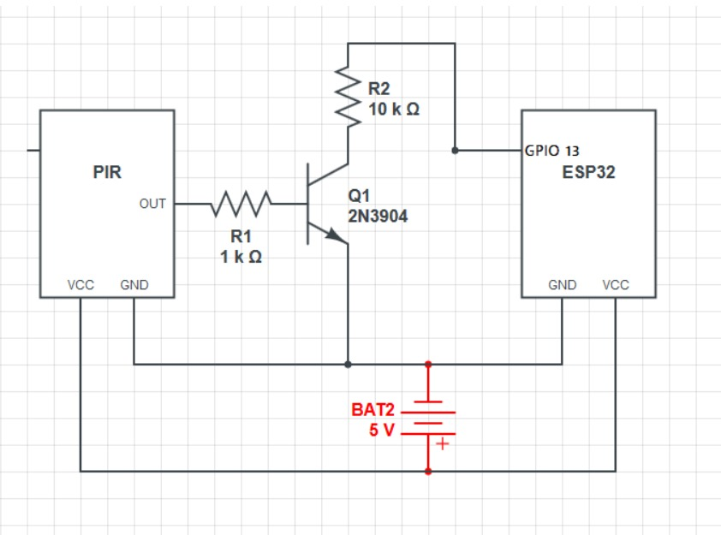

## HARDWARE DETAILS:

|  |  |  |
| --- | --- | --- |
| **S/NO** | **COMPONENTS** | **COST IN ₹** |
| 1 | PIR Motion Sensor | 130 |
| 2 | ESP32 Cam | 450 |
| 3 | TTL Programmer | 150 |
| 4 | F-F Jumper Wire | 50 |

**SOFTWARE DETAILS:**

Arduino IDE

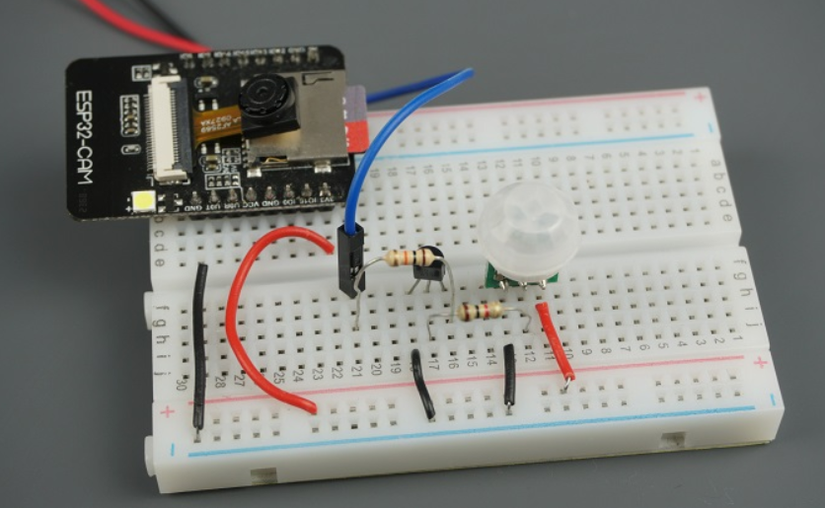





# DESCRIPTION:

1. **Passive Infrared (PIR) Sensor:** The PIR sensor detects changes in infrared radiation within its detection range, typically caused by the movement of people or objects. It consists of pyroelectric sensors that generate electrical signals in response to infrared radiation changes, triggering the detection of motion.
2. **ESP32-CAM Module:** The ESP32-CAM integrates the ESP32 microcontroller and a camera module, allowing for image capture and processing capabilities. It enables wireless communication and supports the storage of captured images on an SD card, making it suitable for standalone surveillance applications.
3. **Integration:** The PIR sensor is connected to the ESP32-CAM module, serving as the trigger for image capture upon detecting motion. When the PIR sensor detects movement, it sends a signal to the ESP32-CAM, prompting it to capture an image using the onboard camera and store it on the SD card.
4. **Application:** This setup finds applications in home security systems, office monitoring, and wildlife observation. It provides a cost-effective solution for capturing images in response to motion events, enabling users to monitor their surroundings remotely and take appropriate action when necessary

**APPLICATIONS:**

1. **Real-time Surveillance:** The system enables real-time monitoring of premises by capturing images upon detecting motion, allowing users to promptly respond to security threats or monitor activity remotely.
2. **Cost-effective Solution:** Compared to commercial surveillance systems, the project offers a cost-effective solution using readily available components such as the PIR sensor, ESP32-CAM module, and SD card for image storage.
3. **Customization and Scalability:** Users can customize and expand the system according to their specific requirements, adding additional sensors or functionalities to enhance security and surveillance capabilities.
4. **Low Power Consumption:** The system operates efficiently, consuming minimal power when idle and activating only when motion is detected, making it suitable for battery-powered or energy-conscious applications.

# OUTCOME OF THE PROJECT:

The successful implementation of the project results in a motion-activated surveillance system capable of capturing and storing images upon detecting motion. Users benefit from enhanced security and situational awareness, enabling them to monitor their surroundings effectively and respond to potential threats in a timely manner. Furthermore, the project demonstrates the integration of sensor technology with microcontroller-based platforms for practical applications in surveillance and monitoring systems. As a result, users gain insights into the principles of motion detection, image processing, and wireless communication, fostering learning and innovation in the field of embedded systems and IoT applications.

# REFERENCES:

1] R. Karthik, V. Karthikeyan, and S. Selva Kumar.

A study on implementation of real-time intelligent video surveillance system based on embedded module

2] A. Mittal, N. Kumar, and M. Saraswati.

Motion Detection for Intelligent Video Surveillance System

3] M. Piccardi and M. A. J. Figo.

Motion detection for video surveillance camera

.